Project Development Phase
Phase 5: Transform Data & Validate
The Project Development Phase involves implementing the planned employee data-import solution in the ServiceNow platform. During this phase, the Excel employee data is loaded into an Import Set, a Transform Map is configured, and the data is transformed into the target table.

1. Environment Setup
- Log in to the ServiceNow instance with appropriate administrative access.
- Verify that the required Import Set and Transform Map functionality is available.
- Prepare the Excel spreadsheet containing employee information.
- Ensure that the spreadsheet has properly formatted column headings and valid data.

2. Preparing Employee Data
The employee spreadsheet is prepared with structured information such as:
Employee ID | Employee Name | Email | Department | Job Title | Phone | Location
EMP001 | Arun Kumar | arun@example.com | IT | Developer | 9876543210 | Chennai
EMP002 | Priya Sharma | priya@example.com | HR | HR Executive | 9876543211 | Bangalore
EMP003 | Ravi Kumar | ravi@example.com | Finance | Accountant | 9876543212 | Mumbai
The data is checked for missing values, incorrect formats, and duplicate employee IDs before importing.

3. Creating the Import Set
The Excel file is uploaded into ServiceNow using the Import Sets functionality.
The Import Set acts as a temporary staging area where the spreadsheet data can be reviewed before it is transferred to the final target table.
Process:
Excel File → Upload → Import Set Table → Review Source Data

4. Creating the Transform Map
A Transform Map is created to define how the imported employee information should be transferred to the target table.
The Transform Map contains the source-to-target field relationships required for the transformation.

5. Configuring Field Mappings
The required source fields are mapped to their corresponding target fields.
Source Field | Target Field
Employee ID | Employee ID
Employee Name | Name
Email | Email
Department | Department
Job Title | Job Title
Phone | Phone
Location | Location
A unique employee identifier can also be used to identify existing records and help prevent duplicate employee entries.

6. Executing the Transformation
After completing the field mappings:
- Open the Import Set.
- Review the imported source records.
- Run the configured Transform Map.
- Monitor the transformation process.
- Check for successful and failed records.
- Review any transformation errors.
The transformed data is then transferred from the Import Set Table into the target employee table.

7. Error Handling
If errors occur during transformation, they are reviewed and corrected. Common issues include:
- Incorrect field mapping.
- Missing mandatory values.
- Invalid email or phone formats.
- Duplicate employee IDs.
- Incorrect data types.
- Missing target fields.
After correcting the source data or configuration, the transformation can be executed again.

8. Data Validation
The imported records are verified in the target table to ensure that:
- Employee records were created successfully.
- Employee IDs are correct.
- Names and contact information are accurate.
- Department and job-title information is correctly mapped.
- No unexpected duplicate records were created.
- The number of imported records matches the expected number.

9. Development Outcome
At the end of the development phase, the complete Excel → Import Set → Transform Map → Target Table workflow will be implemented and tested. The project will provide an efficient method for importing bulk employee data into ServiceNow while reducing manual data entry and maintaining data accuracy.
Transform Data & Validate

Navigation:
- Open Employee Test Table from application navigator as shown below.

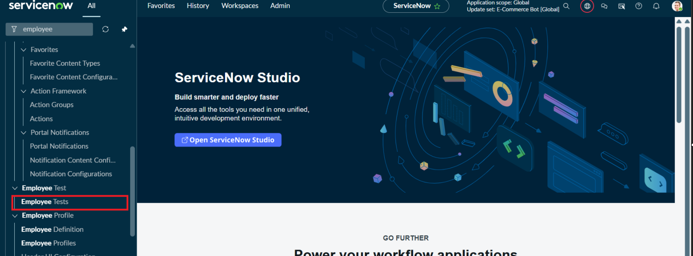

- As our import got succeeded, all the records are created in the Employee Test Table.

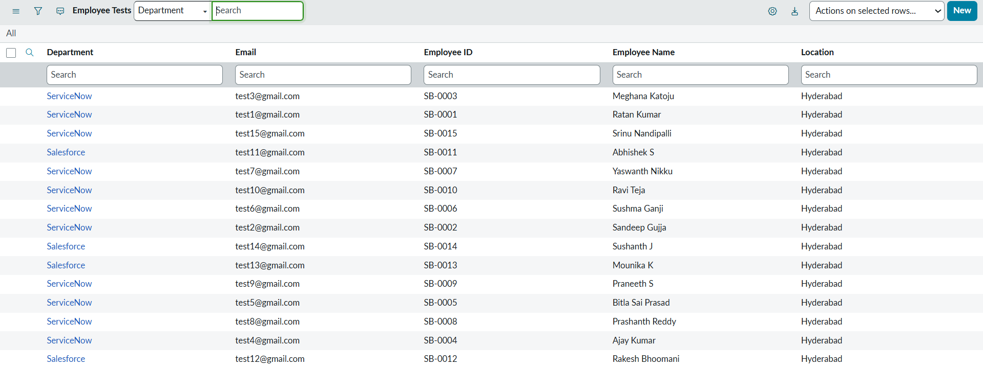

- Make sure you rearrange the fields accordingly by using Personalised List Columns
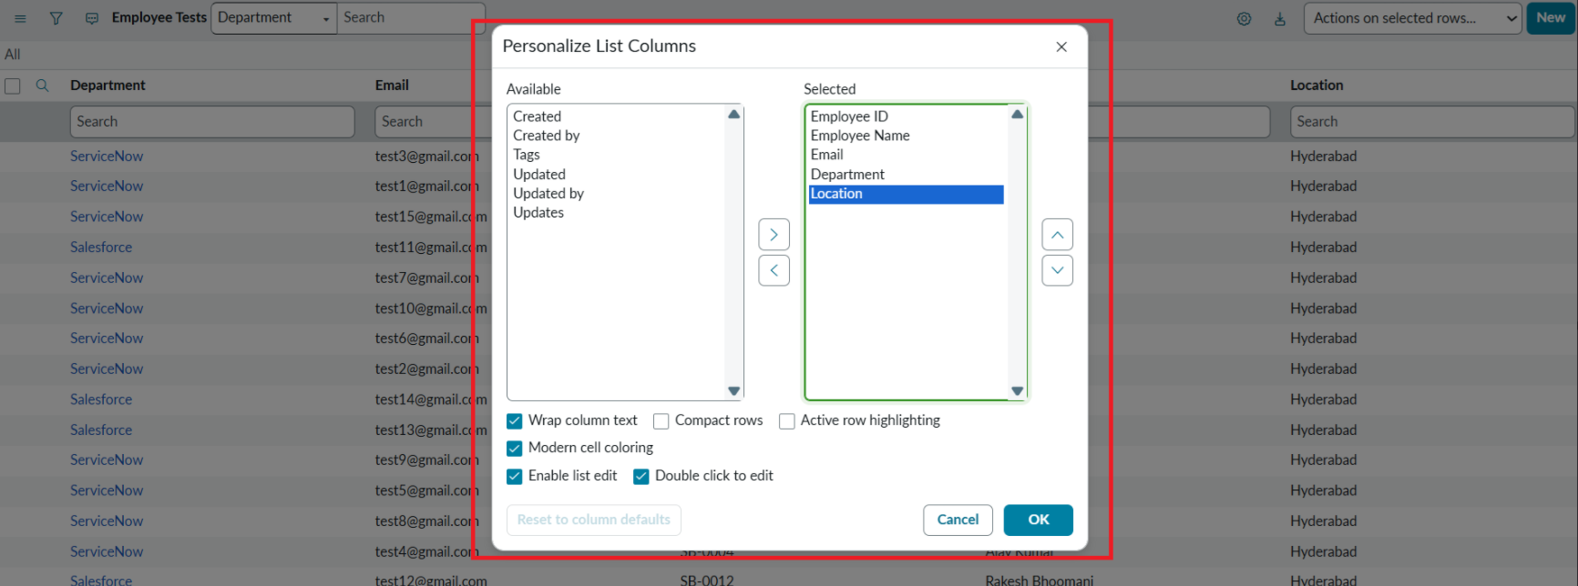

Click on OK

Final Result:
All the records are successfully imported into the ServiceNow system with Import Set, Transform Map.

